**Project Overview**:

To develop an application that enables in providing help to the less privileged, old age homes, orphanages. The concept is based on connecting different people by providing an opportunity to help community by solving their basic issues like food, clothing, study materials requirements etc. to the needy people through this Application.

**Key Functionalities**:

1. Social Service Enterprise:

* Providing help to needy people through Help Provider Organization.
* Requesting help through Help Seekers Organization.
* Working as an inter-mediatory between needy people and volunteers, suppliers with the help of NGO.
* Providing manpower with the help of Volunteer Organization to NGOs as per their work type and requests.

1. Supplier Enterprise:
   * + Supplying the materials requested by help seekers towards the NGO.
     + Donating the materials with the help of Donor Organization to Suppliers which in turn is provided to the NGOs.

**Entities**:

1. Help Provider Organization: Acts on the requests made by NGOs and Help Seekers Organization.
2. Help Seeker Organization: Sends a request to Help Provider Organization and Volunteer Organization, asking them to act on various social issues.
3. NGO: Conducts various Social Events and Awareness Drives to educate people of social issues with the help of Volunteers.

Distribute supplies(food, clothing, shelter etc.) from Supplier to needy people with the help Volunteers.

1. Volunteer Organization: Help in providing manpower to NGO to conduct various Social Events and Awareness Drives.
2. Donor Organization: Forwards the materials collected from donors to Supplier Organization.
3. Supplier Organization: Collects the charity from Donor Organization and forwards it to the NGOs.

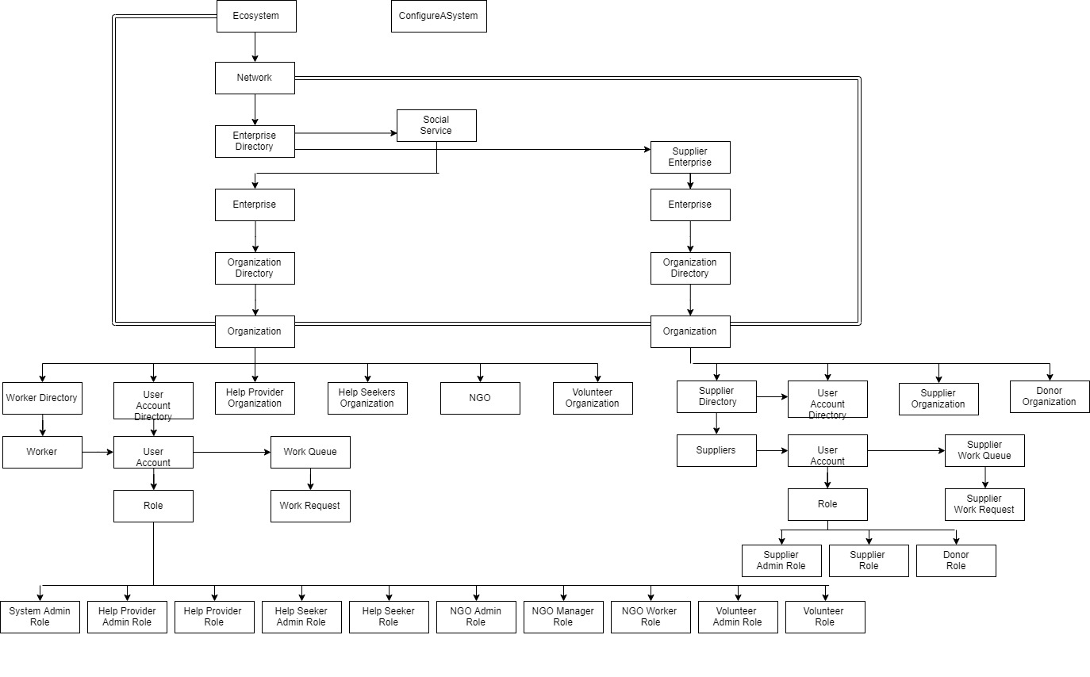

**Enterprise Architecture Diagram**

Additya Shekhar Dharangaonkar

Samarth Hadawale

Rohan Kapadnis